Melissa Meline

May 23, 2017

**Tutorial 7-1** pages 399 – 401

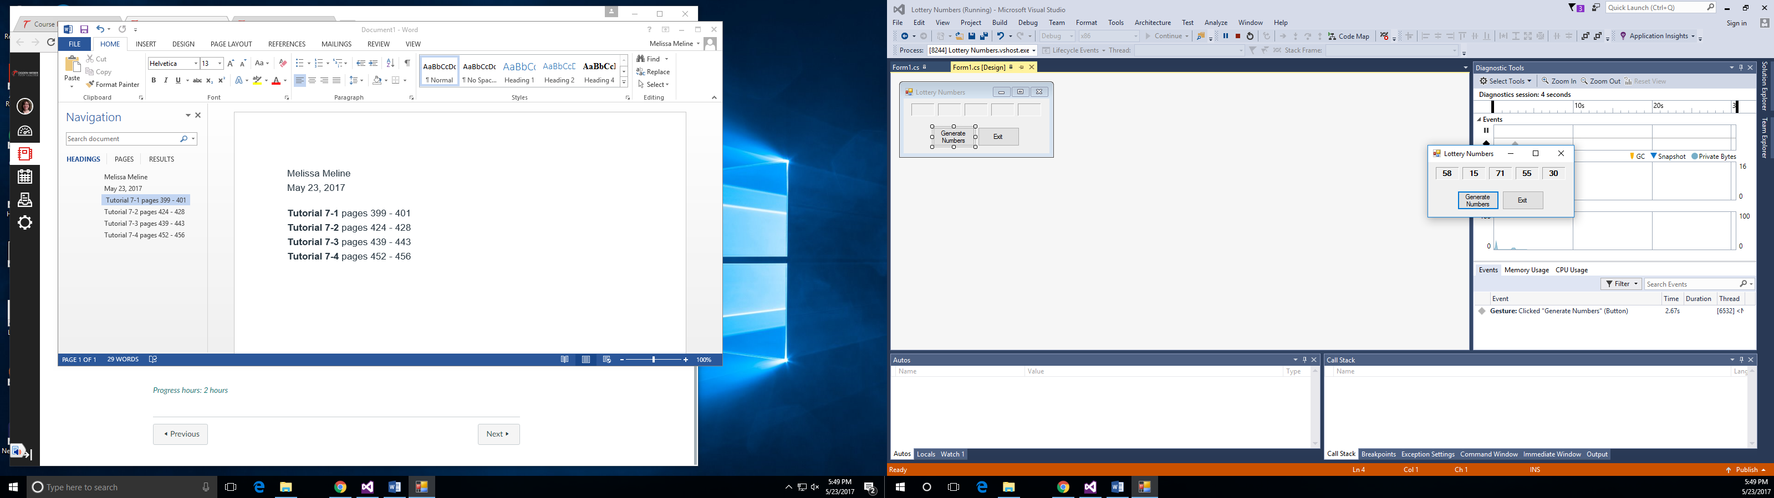

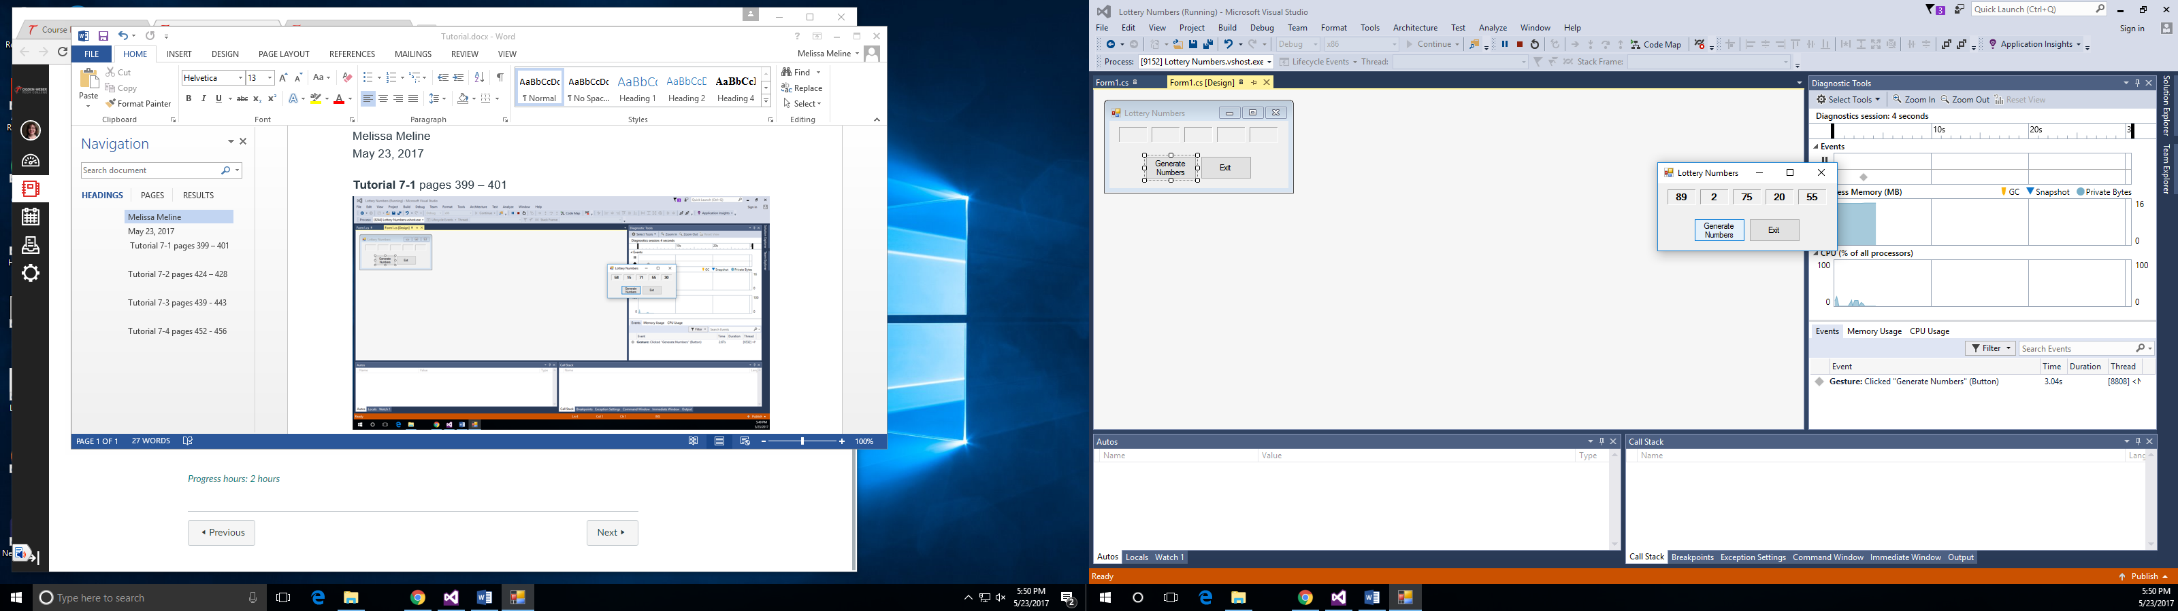

**Tutorial 7-2** pages 424 – 428

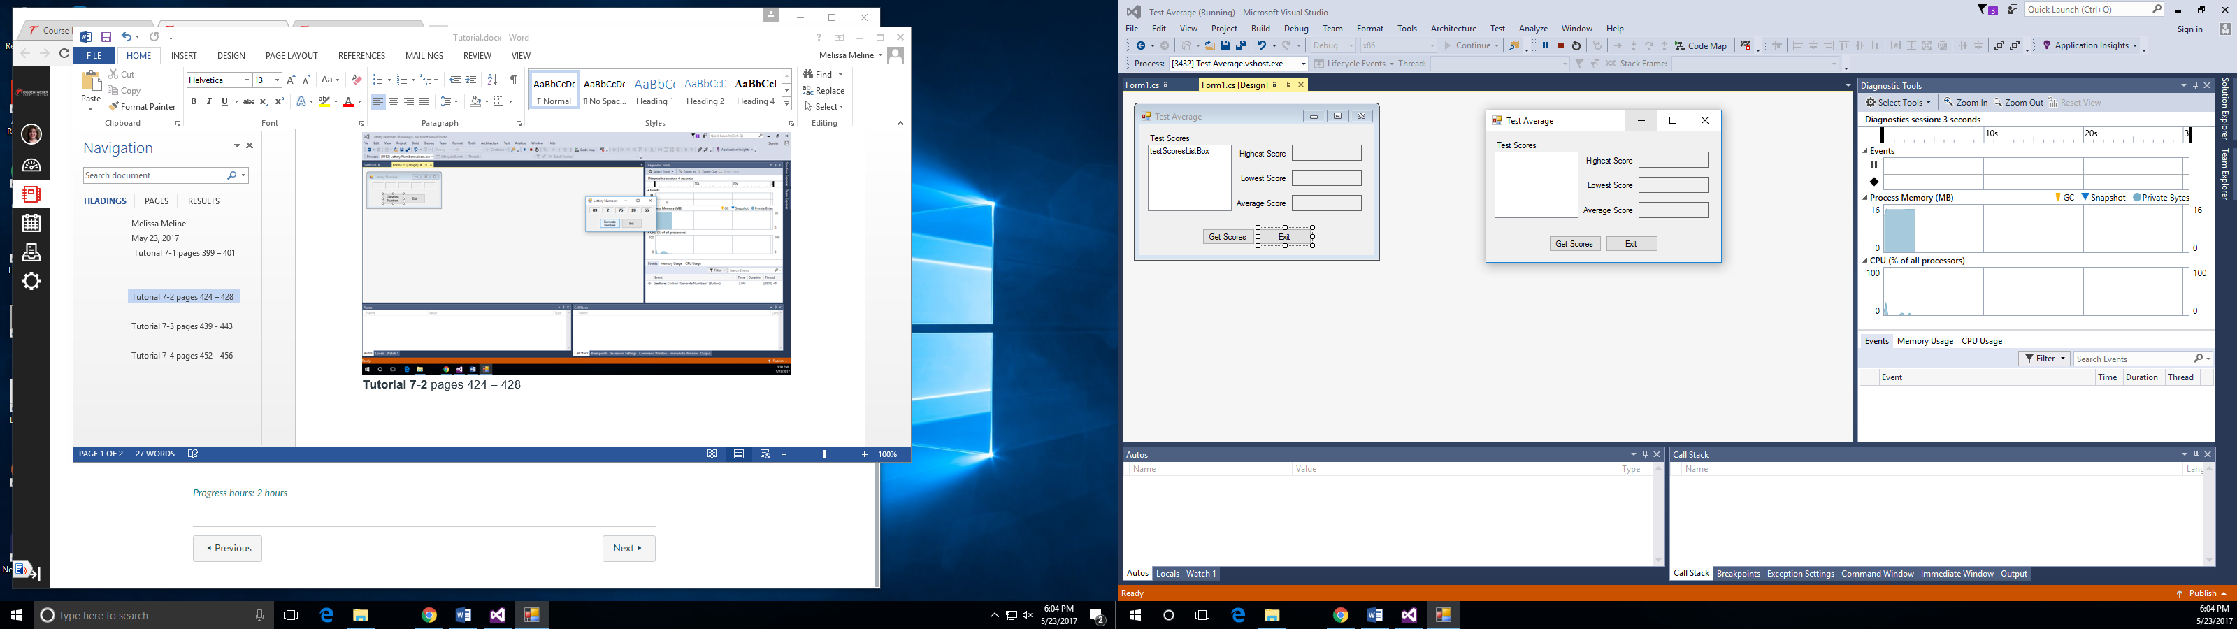

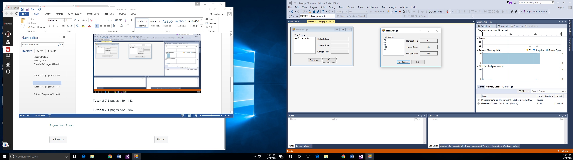

**Tutorial 7-3** pages 439 - 443

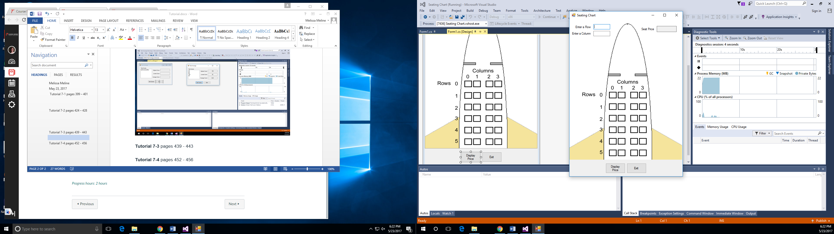

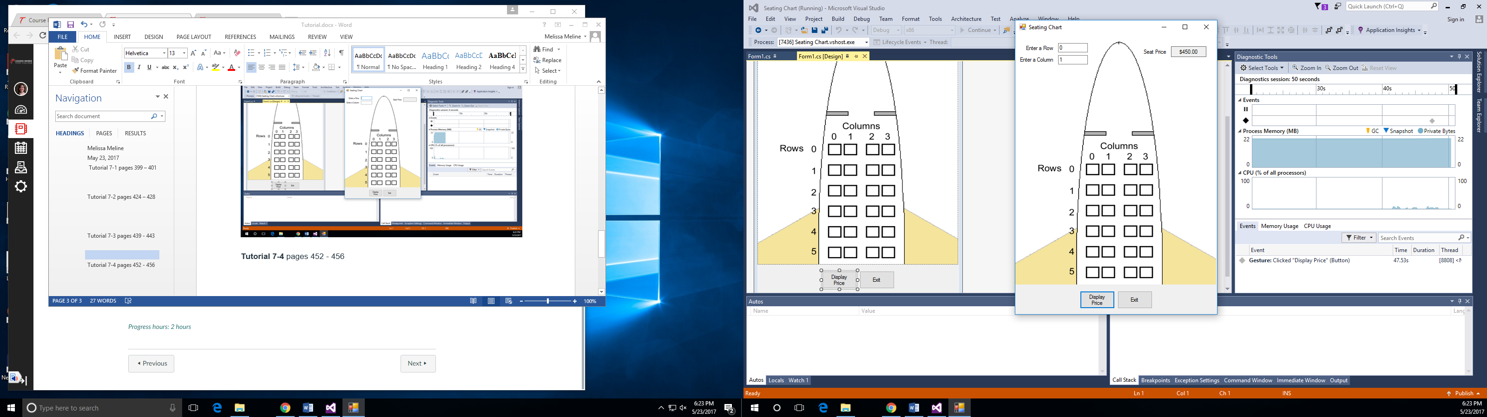

**Tutorial 7-4** pages 452 - 456

